**RNA Helicase Database: Updates**

**Home:**

Welcome to the RNA helicase database.

This is the updated version of the RNA helicase database from 2010.

The RNA helicase database provides systematic and curated information on RNA helicases, enzymes that bind and remodel RNA and RNA-protein complexes in an ATP-dependent manner. In eukaryotes, different RNA helicases are involved in essentially all aspects of RNA metabolism (**Figure**). RNA helicases are also found in bacteria and in many viruses. Mutations and deregulation of RNA helicases have been linked to numerous diseases including cancers, neurological diseases, and developmental defects. Several helicases are important host-factors for infectious diseases and viral RNA helicases represent targets for the development of antiviral therapeutics.

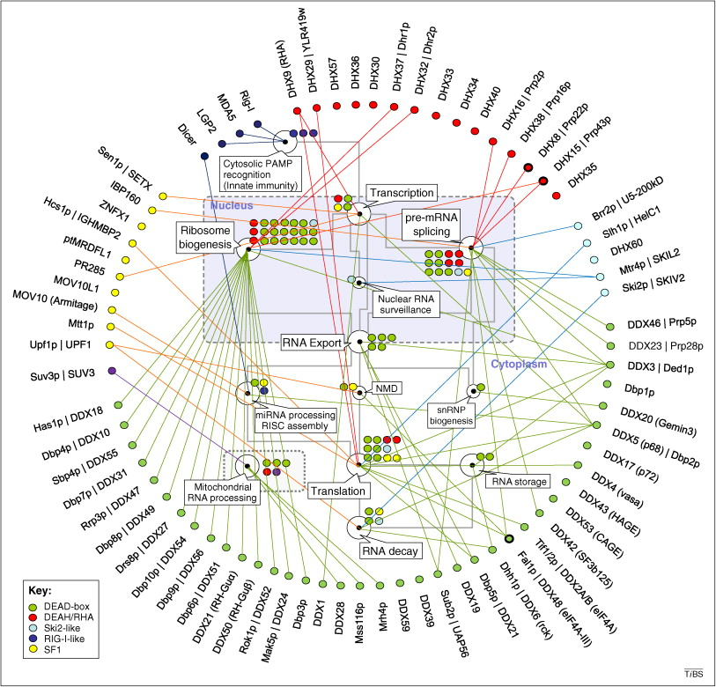

Cellular roles of eukaryotic RNA helicases. Selected processes of eukaryotic RNA metabolism are represented by the white circles, as indicated by the callouts (NMD, nonsense mediated decay). The grey lines mark connections between processes. The colored circles represent individual RNA helicases involved in a given process (Figure from: Jankowsky E, Trends Biochem Sci 36, 19-29 (2011); doi: 10.1016/j.tibs.2010.07.008)

If you use this database in published research, please cite the following reference:   
Jankowsky *et al*., Nucleic Acids Research 39, D338-341 (2011); doi: 10.1093/nar/gkq1002

**Reviews**

**General RNA helicase reviews:**

Jarmoskaite I, Russell R.

RNA helicase proteins as chaperones and remodelers.

Annu Rev Biochem. 2014; 83: 697-725.

doi: 10.1146/annurev-biochem-060713-035546.

PMID: 24635478 PMCID: PMC4143424

Jankowsky E.

RNA helicases at work: binding and rearranging.

Trends Biochem Sci. 2011; 36: 19-29.

doi: 10.1016/j.tibs.2010.07.008.

PMID: 20813532; PMCID: PMC3017212.

Fairman-Williams ME, Guenther UP, Jankowsky E.

SF1 and SF2 helicases: family matters.

Curr Opin Struct Biol. 2010; 20: 313-24.

doi: 10.1016/j.sbi.2010.03.011.

PMID: 20456941; PMCID: PMC2916977.

**Reviews on RNA helicase families and subfamilies:**

Xing Z, Ma WK, Tran EJ. The DDX5/Dbp2 subfamily of DEAD-box RNA helicases.

Wiley Interdiscip Rev RNA. 2019 Mar;10(2):e1519. doi: 10.1002/wrna.1519. Epub

2018 Dec 2. PMID: 30506978; PMCID: PMC6560643.

Sloan KE, Bohnsack MT. Unravelling the Mechanisms of RNA Helicase Regulation.

Trends Biochem Sci. 2018 Apr;43(4):237-250. doi: 10.1016/j.tibs.2018.02.001.

Epub 2018 Feb 24. PMID: 29486979.

Gilman B, Tijerina P, Russell R. Distinct RNA-unwinding mechanisms of DEAD-

box and DEAH-box RNA helicase proteins in remodeling structured RNAs and RNPs.

Biochem Soc Trans. 2017 Dec 15;45(6):1313-1321. doi: 10.1042/BST20170095. Epub

2017 Nov 17. PMID: 29150525; PMCID: PMC5960804.

Lee T, Pelletier J. The biology of DHX9 and its potential as a therapeutic

target. Oncotarget. 2016 Jul 5;7(27):42716-42739. doi: 10.18632/oncotarget.8446.

PMID: 27034008; PMCID: PMC5173168.

Sharma D, Jankowsky E. The Ded1/DDX3 subfamily of DEAD-box RNA helicases.

Crit Rev Biochem Mol Biol. 2014 Jul-Aug;49(4):343-60. doi:

10.3109/10409238.2014.931339. PMID: 25039764.

Putnam AA, Jankowsky E. DEAD-box helicases as integrators of RNA, nucleotide and protein binding.

Biochim Biophys Acta. 2013 Aug;1829(8):884-93. doi: 10.1016/j.bbagrm.2013.02.002. PMID: 23416748; PMCID: PMC3661757.

Fuller-Pace FV. DEAD box RNA helicase functions in cancer. RNA Biol. 2013

Jan;10(1):121-32. doi: 10.4161/rna.23312. Epub 2013 Jan 1. PMID: 23353573;

PMCID: PMC3590229.

Johnson SJ, Jackson RN. Ski2-like RNA helicase structures: common themes and

complex assemblies. RNA Biol. 2013 Jan;10(1):33-43. doi: 10.4161/rna.22101. Epub

2012 Sep 20. PMID: 22995828; PMCID: PMC3590235.

Russell R, Jarmoskaite I, Lambowitz AM. Toward a molecular understanding of

RNA remodeling by DEAD-box proteins. RNA Biol. 2013 Jan;10(1):44-55. doi:

10.4161/rna.22210. Epub 2012 Sep 20. PMID: 22995827; PMCID: PMC3590237.

Martin R, Straub AU, Doebele C, Bohnsack MT. DExD/H-box RNA helicases in

ribosome biogenesis. RNA Biol. 2013 Jan;10(1):4-18. doi: 10.4161/rna.21879. Epub

2012 Aug 24. PMID: 22922795; PMCID: PMC3590236.

Steimer L, Klostermeier D. RNA helicases in infection and disease. RNA Biol.

2012 Jun;9(6):751-71. doi: 10.4161/rna.20090. Epub 2012 Jun 1. PMID: 22699555.

Henn A, Bradley MJ, De La Cruz EM. ATP utilization and RNA conformational

rearrangement by DEAD-box proteins. Annu Rev Biophys. 2012;41:247-67. doi:

10.1146/annurev-biophys-050511-102243. Epub 2012 Feb 13. PMID: 22404686.

Schröder M. Viruses and the human DEAD-box helicase DDX3: inhibition or

exploitation? Biochem Soc Trans. 2011 Apr;39(2):679-83. doi: 10.1042/BST0390679.

PMID: 21428961.

Jarmoskaite I, Russell R. DEAD-box proteins as RNA helicases and chaperones.

Wiley Interdiscip Rev RNA. 2011 Jan-Feb;2(1):135-52. doi: 10.1002/wrna.50. PMID:

21297876; PMCID: PMC3032546.

Linder P, Jankowsky E. From unwinding to clamping - the DEAD box RNA helicase family.

Nat Rev Mol Cell Biol. 2011 Jul 22;12(8):505-16. doi: 10.1038/nrm3154. PMID: 21779027.

**Books on RNA helicases**

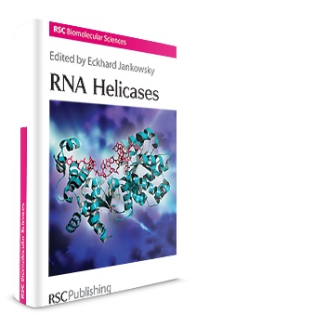

Jankowsky E (ed.) "RNA helicases",

RSC Biomolecular Series 19, Royal Society of Chemistry, London (2010) ISBN 978-1-84755-914-2

<https://pubs.rsc.org/en/content/ebook/9781847559142>

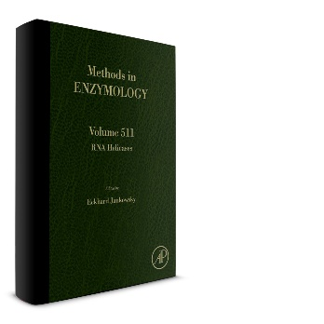

Jankowsky E (ed.) "RNA helicases: analysis of molecular mechanisms and cellular functions."

Methods in Enzymology 512 (2012)

<https://www.sciencedirect.com/bookseries/methods-in-enzymology/vol/511/suppl/C>

**About the database:**

RNA helicases fall into well-defined families, subfamilies and groups (1). We have structured the information in the database accordingly.

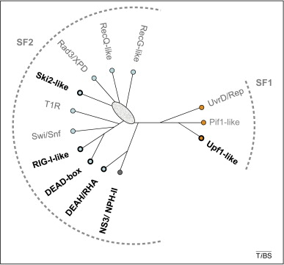

Eukaryotic helicase families. Unrooted cladogram showing the families of the SF1 and SF2 (1). Boldfaced names show helicase families with RNA helicases. These names are used in the database. Not all helicases in these families are RNA helicases (non-standard abbreviations: T1R, type 1 restriction enzymes; RHA, RNA helicase A).

Because of the constant influx of new information, we are unable to provide comprehensive coverage of all known RNA helicases. We focus the database on RNA helicases from S. cerevisiae, C. elegans, M. musculus, and H. sapiens, and representative viral and bacterial proteins. Besides curated information on RNA helicases from the selected organisms, the database also contains auxiliary information, including a list of reviews, and a list with the naming code for RNA helicases.

The database was created by Soon Yi, Anja Jankowsky, and Eckhard Jankowsky. Eckhard developed the concept. Technical and graphical implementation were realized by Soon and Anja. The scientific content was compiled by Anja and Eckhard with help from Maggie Fairman.

Eckhard Jankowsky is Professor at the Center for RNA Science and Therapeutics at Case Western Reserve University in Cleveland, Ohio. Soon Yi is an MD-PhD student in his group. Work in the Jankowsky lab is focusing on roles and mechanisms of RNA helicases and other proteins that interact with RNA.

(jankowskylab.org)

***Reference:***

1. Fairman-Williams ME, Guenther UP, Jankowsky E. SF1 and SF2 helicases: family matters. Curr Opin Struct Biol. 2010; 20: 313-24. doi: 10.1016/j.sbi.2010.03.011. PMID: 20456941; PMCID: PMC2916977.

***Contact: as is on website***